Report layout

Task to solve with the help of data mart from DWH:

‘I want to compare sales cost and sales quantity of brand-new products with other popular products that company used to sell over the last years so as to see the %difference in interest of consumers’

One of the concepts of final report is shown on the screenshot below:

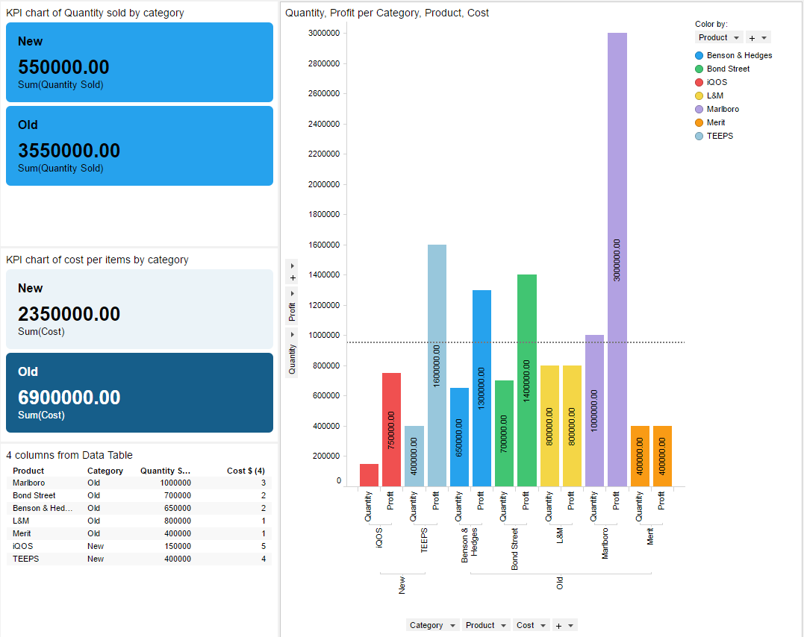

**Picture – concept of final report**

This report shows some main goals that were set on the first step of building DWH. One of the task was to find the difference between sales start of new product compared to the already known production. This question appeared because of the small profit after new production line had started.

This concept report was built in TIBCO Spotfire on the example-basis values and real production items. It includes:

* 2 KPI charts (on the left of the screen) where
  + 1st chart shows total Quantity sold per category on its the first year on market;
  + 2nd chart shows total profit per category on its first year on market;

* total profit is a calculated column where [quantity] was multiplied on [cost per item]

* Bar Chart (on the right of the screen) where there is a quantity and profit on value axis per products (grouped by categories). There is also a line that shows average quantity sold in the first year of the product on the market.

Such charts provides easy-to-understand access to the success of the products in their market sales starts.